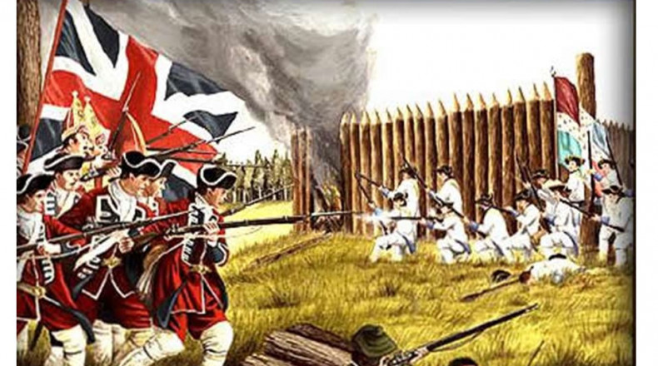

Imperial Crisis

We discussed the various reasons why settlers moved to the New World. With the focus on Britain, many moved to America for financial opportunities. The wealthy landowners sought to claim even more land for themselves. The lower classes, such as the serfs (peasants) who did not own land, ventured to the New World for the same reason; to try and claim land in America. Typically, serfs could not afford the journey and Lords, or landowners would sponsor their passage and in return, the peasant would be indebted to the Lord. Debts were paid in labor (approximately five to seven years). This system was known as Indentured Servitude.

A simple way to put it was that a rich man from Britain would pay for a poor man to go to America. The poor man would settle his debt by working for the rich man when he got to the New World (I say man, because Lords and Indentured Servants were virtually all men). Indentured Servants would leave their families behind with the hopes that one day, they will have settled their own land, harvested it to a profit and pay for his family to join him in America. Most of the time, that did not happen.

Settlers formed Colonies. A colony was a territory in the New World that was politically compliant with the Mother Country (Great Britain in this case). Jamestown was the first British Colony in America. The folks who lived in Jamestown, though they were an ocean away, were formally, still British subjects. The financial relationship between the colony and the Mother Country was known as Mercantilism.
Mercantilism worked like this: The colonists would sell raw materials to the Mother Country, let’s say timber. The Mother Country’s factories and shops would use the timber to produce finished products: furniture. The furniture was then sent back to the colonies and sold to the colonists.
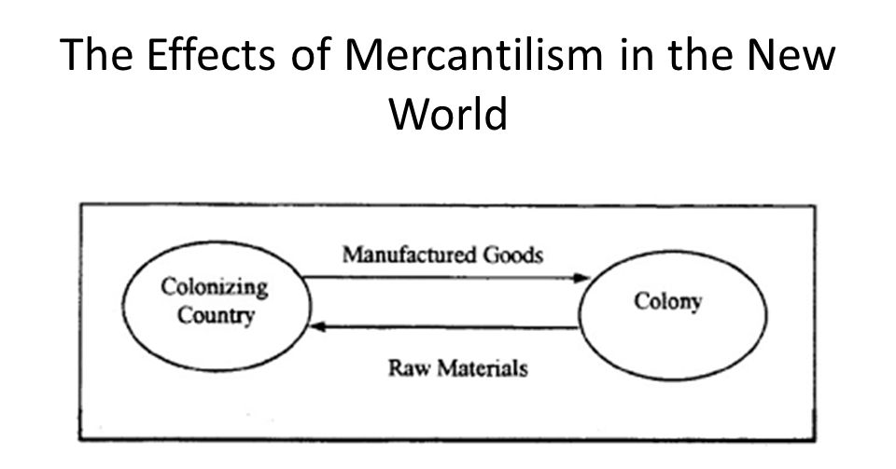
This was an ideal system because both parties did very well regarding profit and for the most part, the relationship between the Colonists and Mother Country was mutually beneficial. England needed wood and America had plenty of it. Americans needed chairs but had no shops or factories to produce them. Simple solution: send the wood from America to England, that wood is used to build chairs, send the chairs to America.

The French and Indian War/The Seven Year’s War
Without getting bogged down in the details, historically, Britain and France were bitter rivals who were often at war. One such war was known as the Seven Years’ War. France and Britain both had claims on land in the New World. The Ohio Valley and Quebec were two areas that France and Britain maintained to be their territory. The war was more involved than that, but for our purposes, that is all that matters. The King of England at the time, George II, needed the American colonists to help defeat the French. The Americans were on the fence about this and didn’t see an immediate need to enter the war. In order to persuade them, the king offered two promises: 1: When the war is over, the disputed territories of Ohio and Quebec will be given to the Americans. 2: The Kings’ men would protect the colonists from Indians and possible French reprisals or revenge.

For the most part, the colonists were still divided. Some thought it was a good offer and felt duty bound to defend the kingdom. Others felt that part of the reason they left Europe was to avoid these types of conflicts. In 1754, Ben Franklin invited each of the American colonies to send delegates to Albany, New York to debate and discuss the best course to move forward. This meeting was known as the Albany Congress. The Albany Congress was incredibly important, why?
Because it was not only a meeting to decide the best course of action with regard to the Seven Year’s War but it was the first time the thirteen American colonies formally came together as one to discuss a common problem.

Franklin’s position was that if all colonies decided to help the king, they could defeat the French Army. If only a few colonies entered the war, they will get crushed. Simply put, his sentiment was that we all do this, or none of us do it. “Join or Die” was a poster Franklin created to express his point of view.

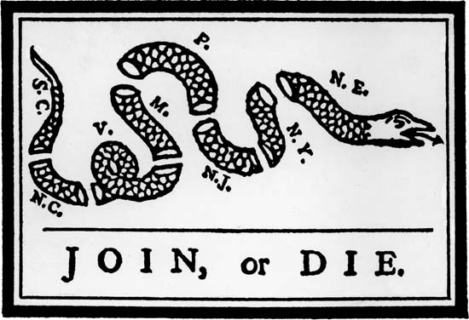

The point needs to be stressed. Prior to 1754, the colonies largely did not care about one another. The colonists in Virginia had no allegiance or consideration of the colonists from say, New York. If Georgia was being attacked by Natives, the folks in Maryland would think “eh…not my problem.” There was no concept of being an American. The only thing the colonists effectively had in common is they were loyal to the Mother Country. Therefore, the Albany Congress was significant, it was the first time the colonists came together as one. (See the snake parts as individual colonies, when separated are useless, when they are together as one snake, they are lethal).

What did the Congress ultimately decide?
They agree to accept King George II’s offer and sided with the British Army. In America the war was known as the French and Indian War. The Americans fought the French and they fought Native Americans who assisted the French Army. Thus, the French and Indian War (The war has two names, sometimes it is known as the Seven Years’ War and other times it is called the French and Indian War, but it is the same war).

We are going to do something a little different for this assignment. The tasks will be broken into three parts.

Part I.
It is 1754 and you are delegate from the colony of New York at the Albany Congress. You must decide on either joining the war for the British or remaining neutral in the latest conflict between the French and the Brits.
Based on Experience History, pages 119-20, The Albany Plan of Union and The War Widens, state your position and then explain why you have reached that conclusion. Remember, you want to try to convince the other delegates to share your opinion (Join or Die). Your response should include relevant, historical fact in supporting your opinion. This should approximately one to three paragraphs and will be worth 2 points.

Part II.
Based on the short video and Chapter Six, answer the three of the questions below (1 point each).
https://www.youtube.com/watch?v=9n-gsgqaUo0
- What role did Native Americans play in the French and Indian War?
- Why did the relationship between the Americans and Brits sour as they fought alongside one another during the war?
- Though the French surrendered, the war was incredibly expensive. How did the King of England attempt to recoup the financial losses incurred in waging the war?
Part III.
Ben Franklin drafted the “Albany Plan of Union” which was an outline for how the united colonies would work together to assist the British Empire during the war. If you think about it, it would be one thing for the colonies to agree to come together to fight the French, but how? How did they raise an army and equip them with weapons? Who paid for all of this? Who would be in charge?

Franklin’s “Albany Plan of Union” attempted to answer all those questions and organize the thirteen colonies.
Task: Based on the text of the Albany Plan of Union (included in the link below) answer the three questions. Make sure to cite or quote the Albany Plan within your answers.
https://founders.archives.gov/documents/Franklin/01-05-02-0104

Why did colonial delegates argue the Albany Plan threatened their sovereignty and did Franklin sufficiently address such a concern?

How could one argue against intervention in the Seven Year’s War given the looming threat of French encroachment upon the colonies?

Why did King George, II discourage the Plan of Union with consideration that the Empire was in desperate need for military assistance?

This is Due Sunday June 27 at 11:59 PM.
Please email me directly with questions, concerns or if you need help ediorio@mercy.edu

